**Cropping Tool**



Shape

**Users Guide v1.1.0**

Contents

[**OVERVIEW3**](bookmark://_Toc447542504)

[**RUNTIME ENVIRONMENT REQUIREMENTS3**](bookmark://_Toc447542505)

[**RUNNABLE JAR LOCATION3**](bookmark://_Toc447542506)

[**HOW TO CONFIGURE3**](bookmark://_Toc447542507)

[Sample Configuration File4](bookmark://_Toc447542508)

[**HOW TO RUN THE TOOL4**](bookmark://_Toc447542509)

[**POSSIBLE ERRORS AND HOW TO FIX IT5**](bookmark://_Toc447542510)

[**VERSION HISTORY5**](bookmark://_Toc447542511)

￼

**Overview**

This document is intended to assist users of Cropping Tool. This document will discuss areas such as how to run the tool, how to setup the configuration file and possible errors to encounter and how to fix it.

**Runtime Environment Requirements**

1. Installed JRE version 1.8 or later.
2. Set Java Memory to At least 1GB or Greater.
3. IO Permission to folders to be accessed by the tool both for INPUT folder and OUTPUT folder.
4. Free filesystem space of at least twice of INPUT data size.

**Runnable Jar Location**

**\\192.168.160.184\internal\ACTIVE** **INTERNAL DATA\Team James\temp\**Cropping tool - 10-2-2018\cropping_tool.jar

**How to Configure**

* The Configuration file can be found in 'config/config.properties' where cropping_tool.jar is located

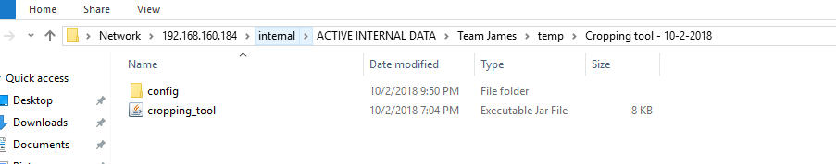

* First you need to configure the input path of the images and input path of the coordinate files. You can also configure the output path or set “N” to let it run in default and the output folder will be in the same parent folder as the input images folder, the output folder will be named “cropped images” if the output is set as default it will create child folders the same as the input images folder. If you set the use output folder to “Y” it will create a “cropped images” folder in the path you set up and put all output there without any folder separators.

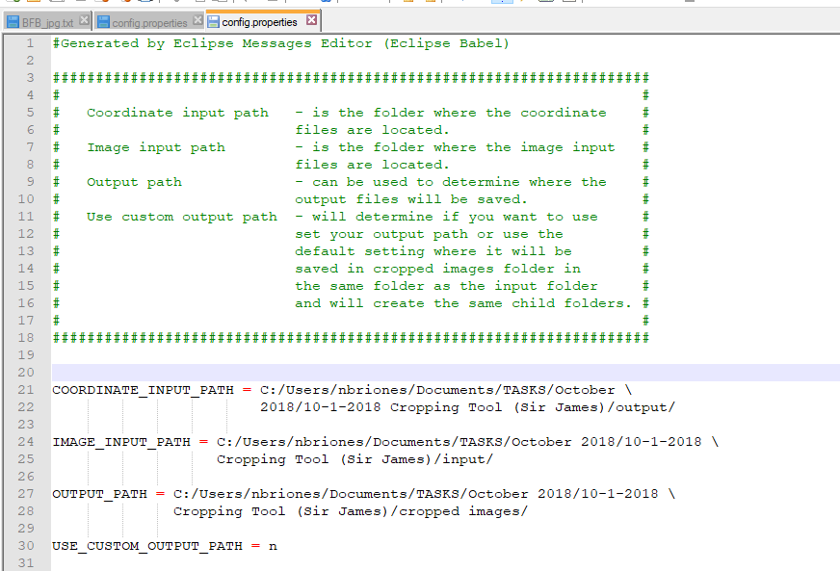

***config.ini***

*The "config.properties" file is divided into a single section, namely [PATHS]*

**[PATHS]** - For configuring the image input path, coordinate input path, output path, and use custom output path.

* IMAGE_INPUT_PATH
  + The path/directory where your input images are stored
  + The images should only be two folders/subdirectories deep in this parent folder/directory else they will not be detected
  + Ex. C:\Users\nbriones\Documents\TASKS\October 2018\10-1-2018 Cropping Tool (Sir James)\input images\
* COORDINATE_INPUT_PATH
  + The path/directory where your corresponding coordinate text files are located
  + The coordinate files should also only be two folder/subdirectories deep int this parent folder/directory.
  + Ex. C:\Users\nbriones\Documents\TASKS\October 2018\10-1-2018 Cropping Tool (Sir James)\input coordinates\
* OUTPUT_PATH
  + The custom output directory where you want to put the output cropped images.
  + Will be used only if you set the “USE_CUSTOM_OUTPUT_PATH” to “Y” else the output will be placed in the same parent directory of the input images folder.
  + The parent directory of the output folder will be named “cropped images”.
  + Ex: C:\Users\nbriones\Documents\TASKS\October 2018\10-1-2018 Cropping Tool (Sir James)\cropped images
* USE_CUSTOM_OUTPUT_PATH
  + Will determine if the output path will be your custom output directory or the default set in the program.
  + Ex.
  + If set as “N”.

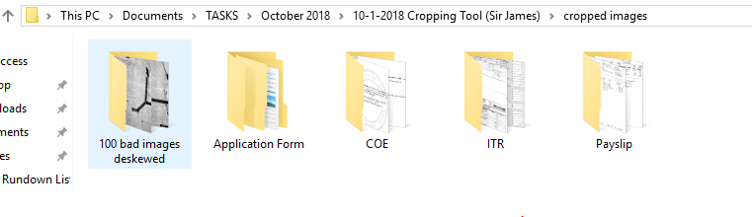

* + If set as “Y”.

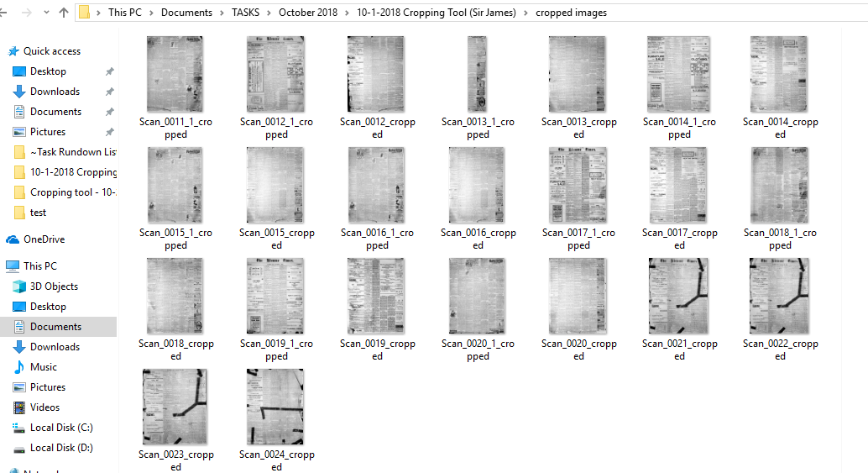

**Sample Input Images folder, Input Coordinates folder and Output folder when Using default output path:**

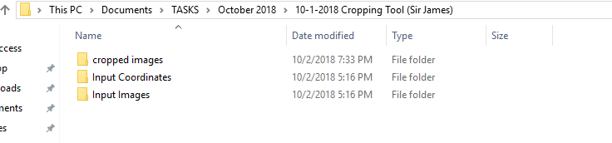

**How to Run the Tool**

1. Open CMD.
2. Input "java -jar [location of the jar file]" and press enter;
3. Wait until “Done Cropping Images.” is displayed.

**Possible Errors and How to Fix it**

|  |  |
| --- | --- |
| **Error** | **Solution** |
| Output folder not found | Check for output folder |
| Input folder not found | Check for input folder |

**Pseudocode:**

For each File in image folder add to imageList;

For each File in coordinate folder add to coordinateList;

For each image in imagelist and each coordinate in coordinateList

If coordinate is image’s coordinate file;

Read coordinate and get outer points;

Compute crop coordinates and size from outer points;

Crop image;

End for;

**Version History**

|  |  |  |  |
| --- | --- | --- | --- |
| Version | Description | Revised by: | Revision Date: |
| 1.0.0 | Revision | Norbert M. Briones | 2018-2-10 |